

M.Tech. Artificial Intelligence & Data Science (Specialization in Cyber Security)

School of Cyber Security and Digital Forensics

Incident Response and Audit Compliances Laboratory

Lab practical Work

Semester: 1

Session: 2024-25

Date: 16/12/2024

|  |  |  |
| --- | --- | --- |
| Submitted to |  | Submitted by |
| Mr. Prakash Khasor Sir |  | Pratham Badge |

**Windows Event Viewer Practical Tasks**

**Practical 1: Basic Navigation and Event Filtering**

**Objective:** Understand how to navigate and filter events in the Event Viewer.

**Steps:**

1. Open Event Viewer (`eventvwr.msc` via the Run dialog).

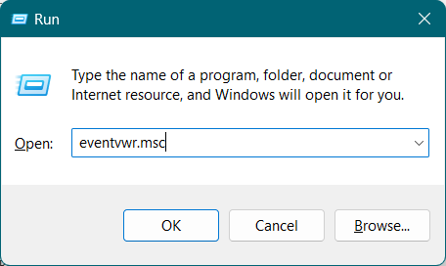

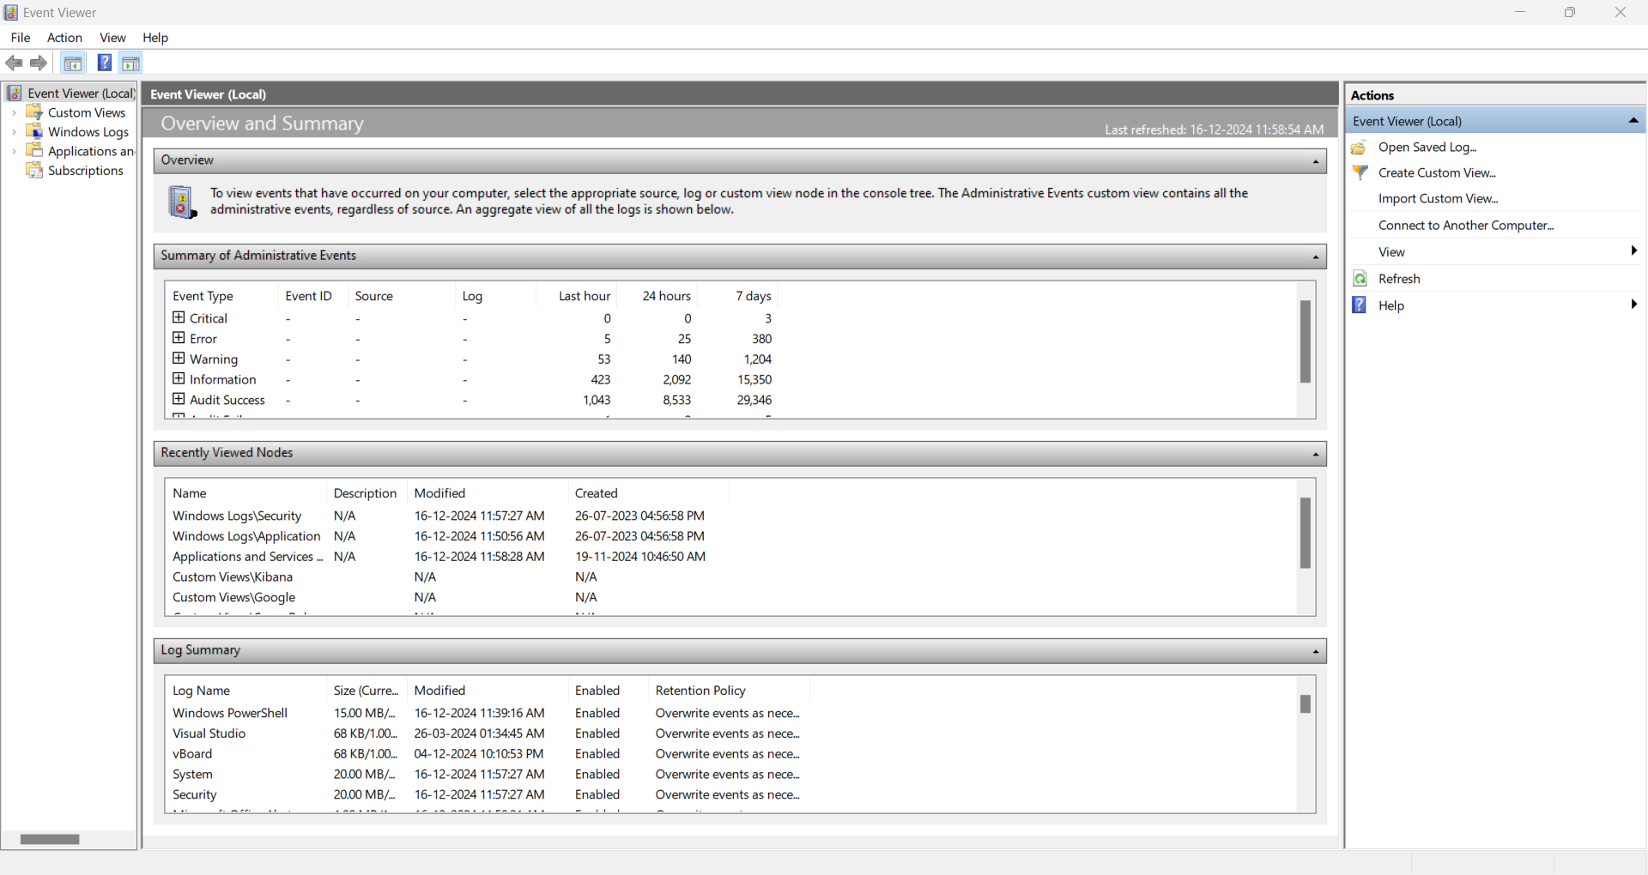

1. Explore the main sections:
   1. - Windows Logs (Application, Security, System, etc.)

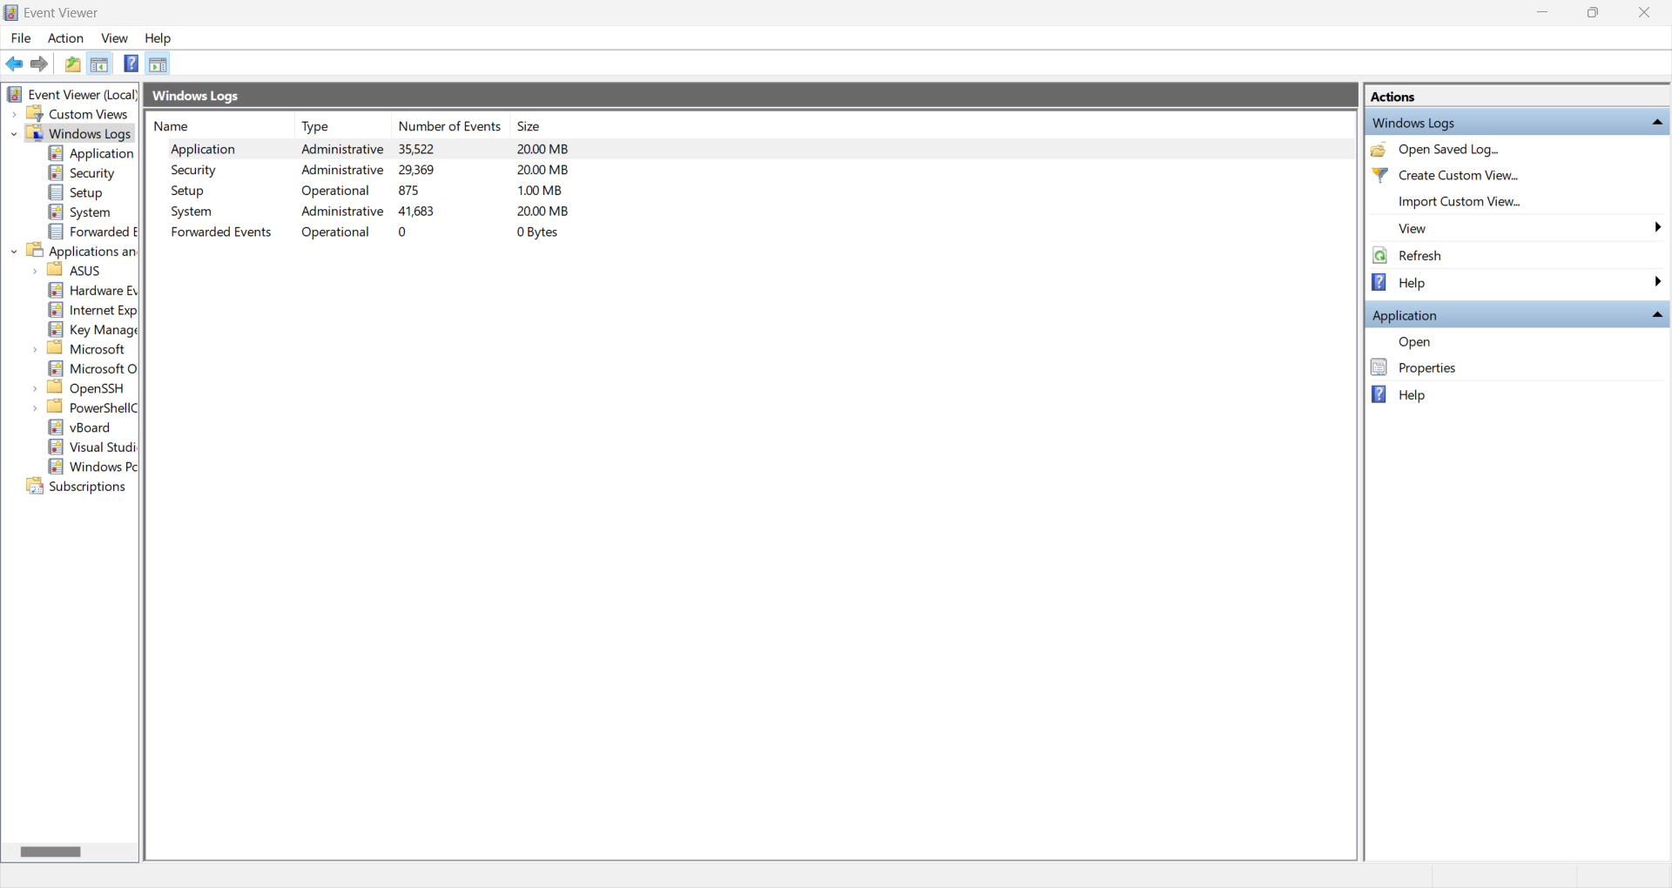

* + 1. Application

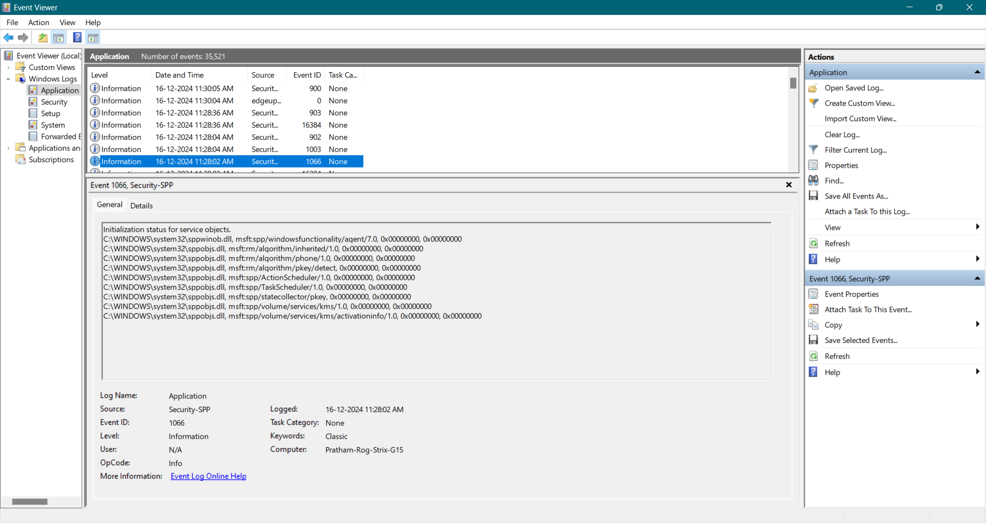

* + 1. Security

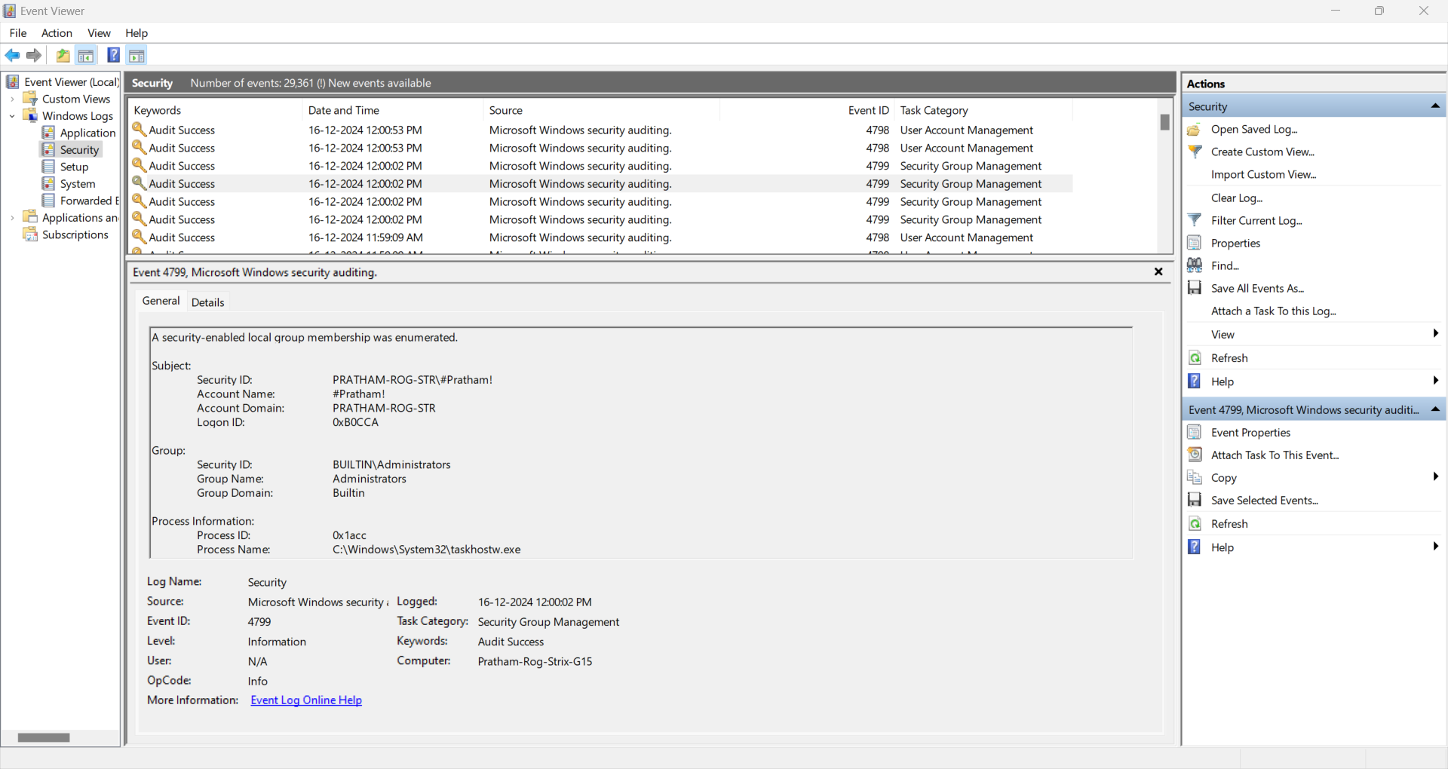

* + 1. System

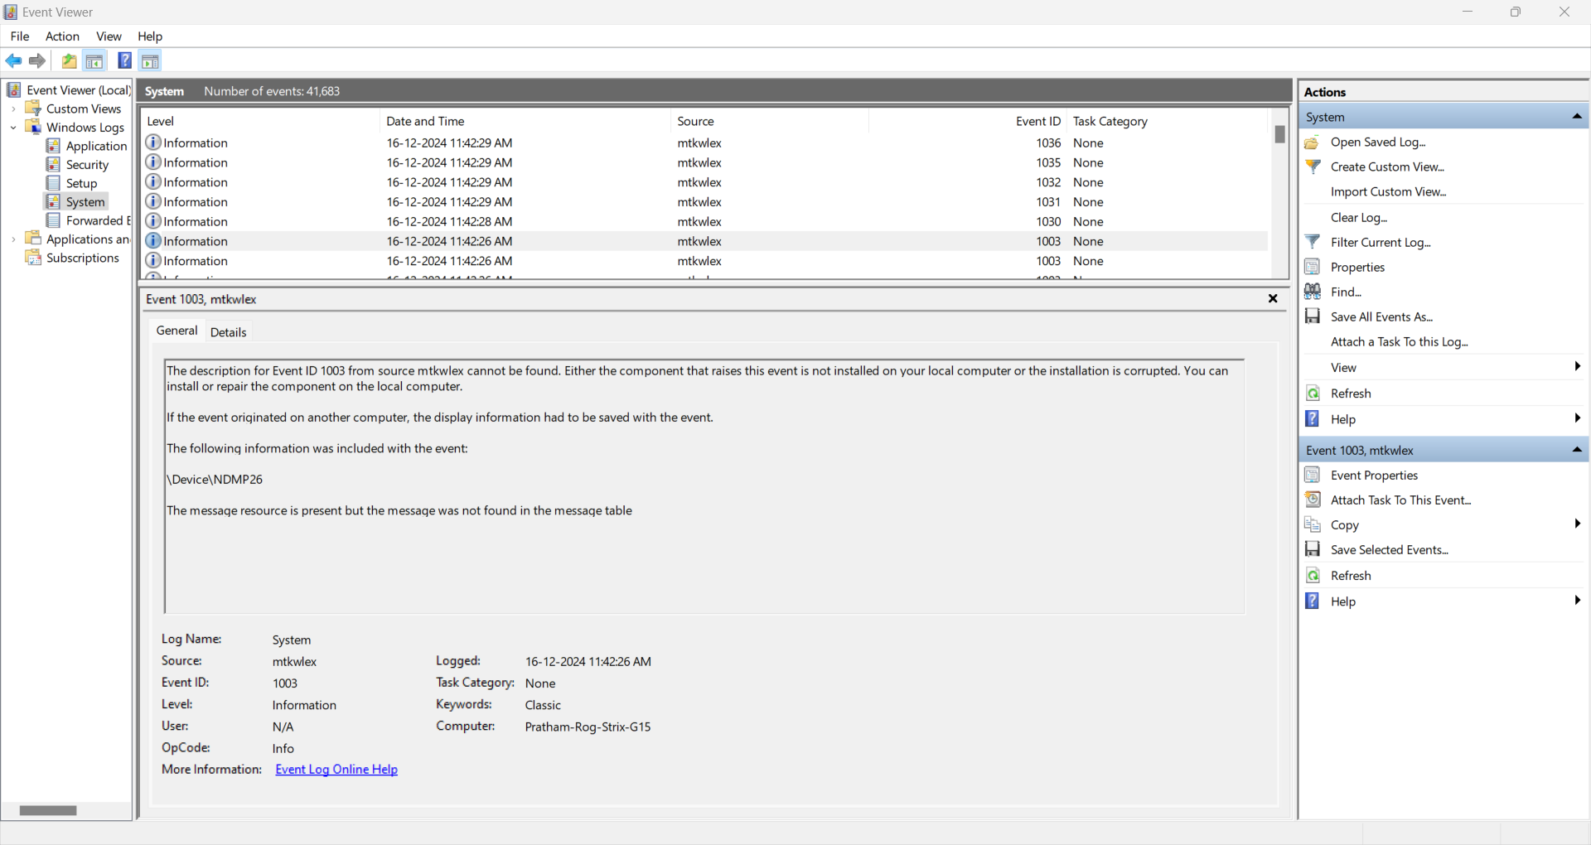

* 1. - Applications and Services Logs.

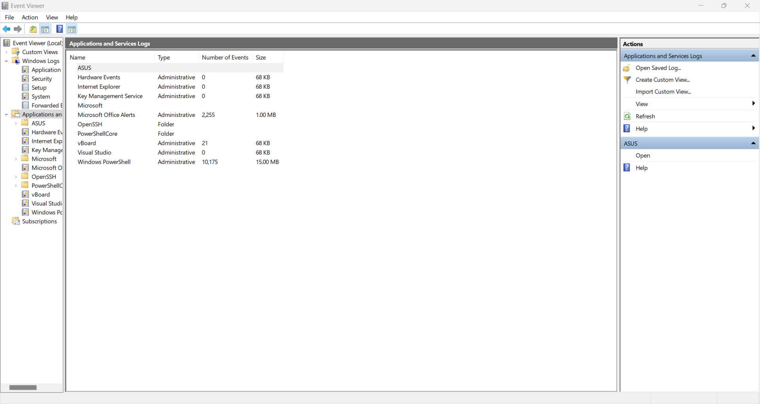

1. Select System Logs and filter by:

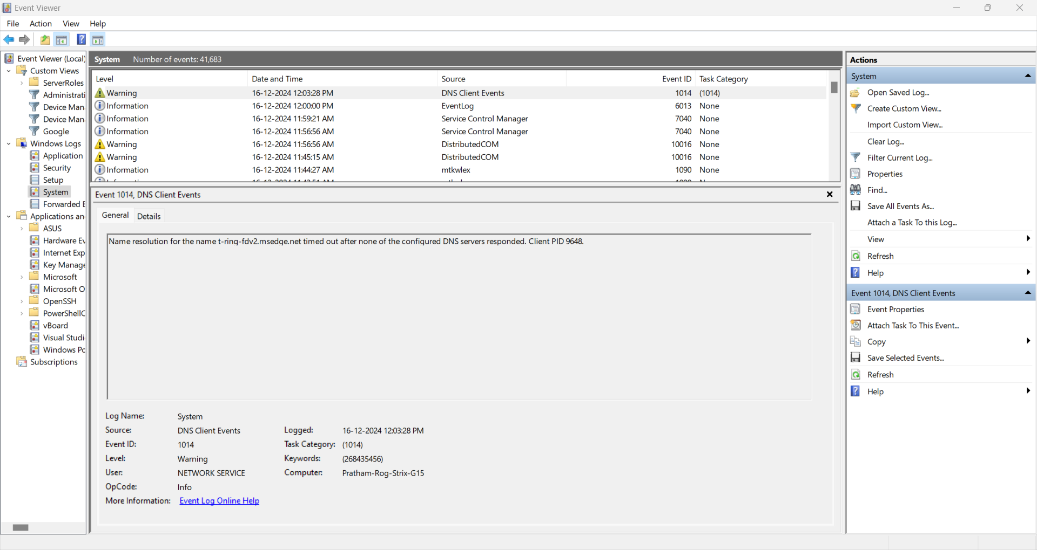

* 1. Event Level (e.g., Errors or Warnings).
     1. Error

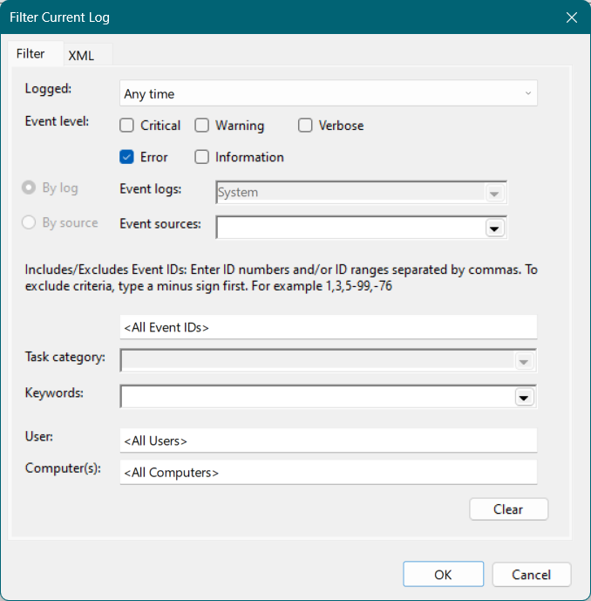

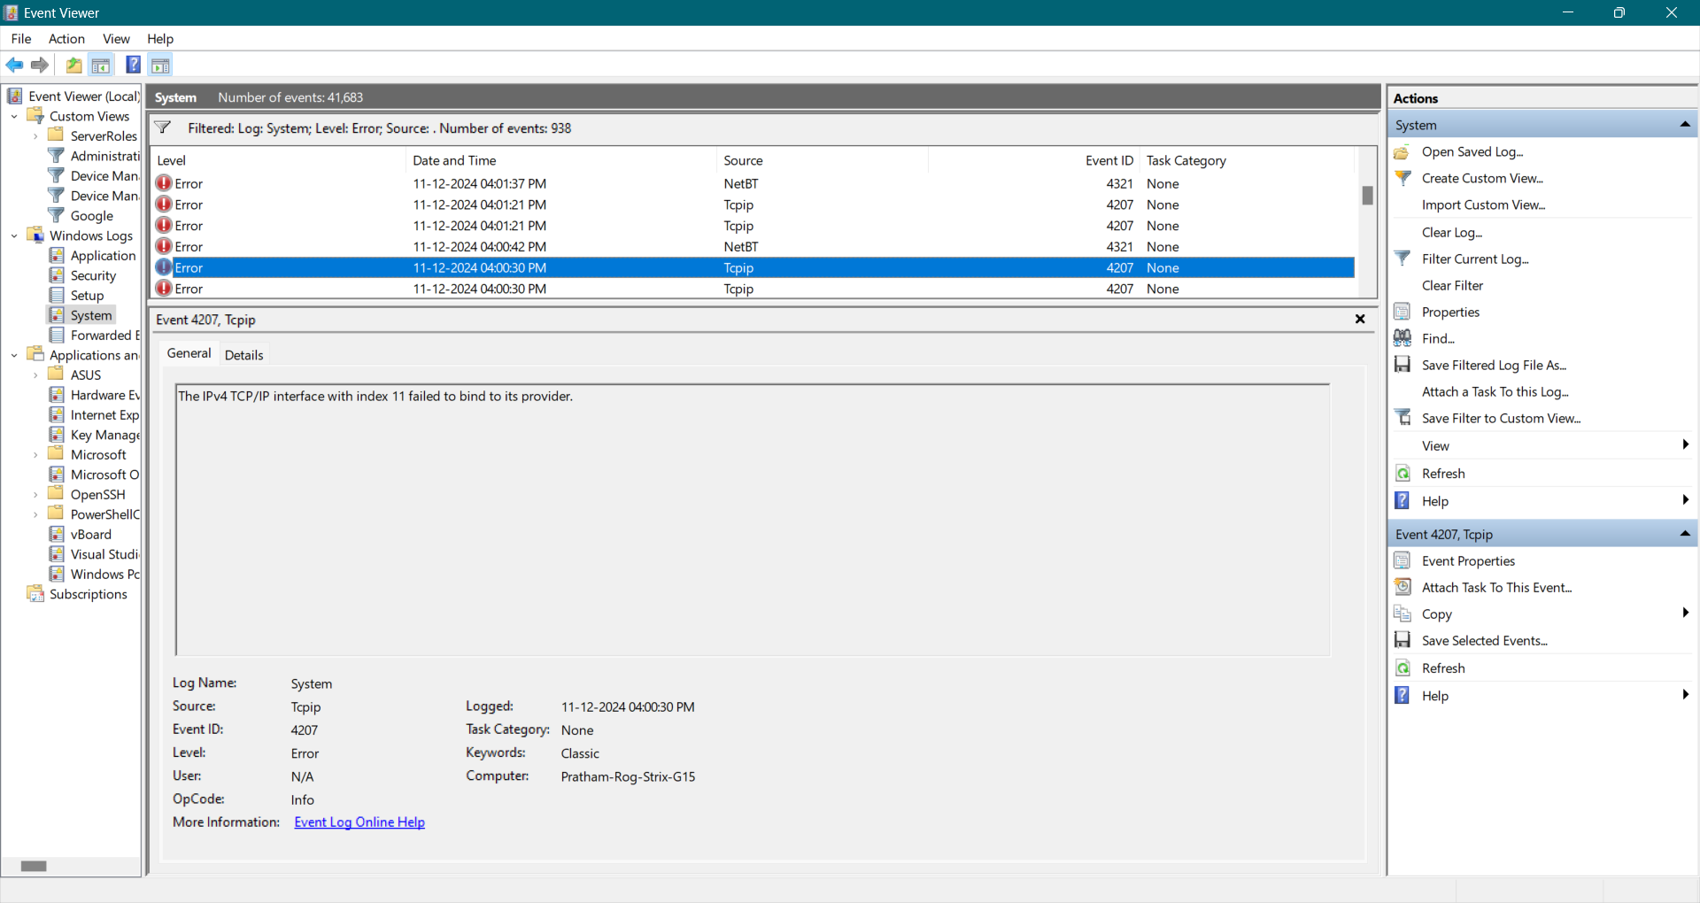

* + 1. Warnings

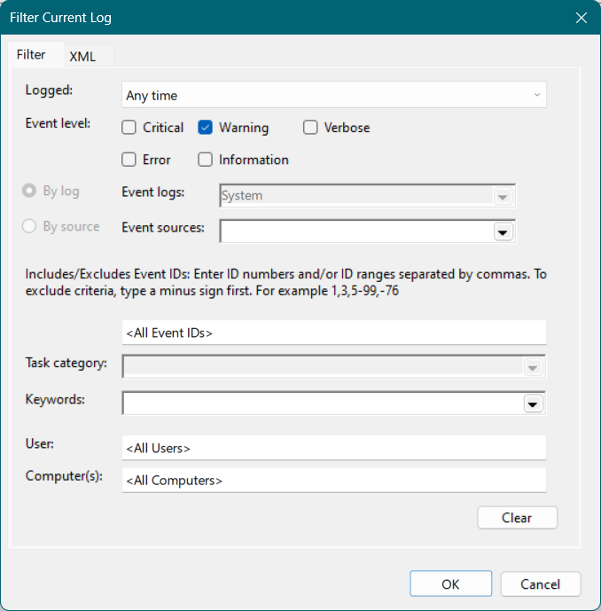

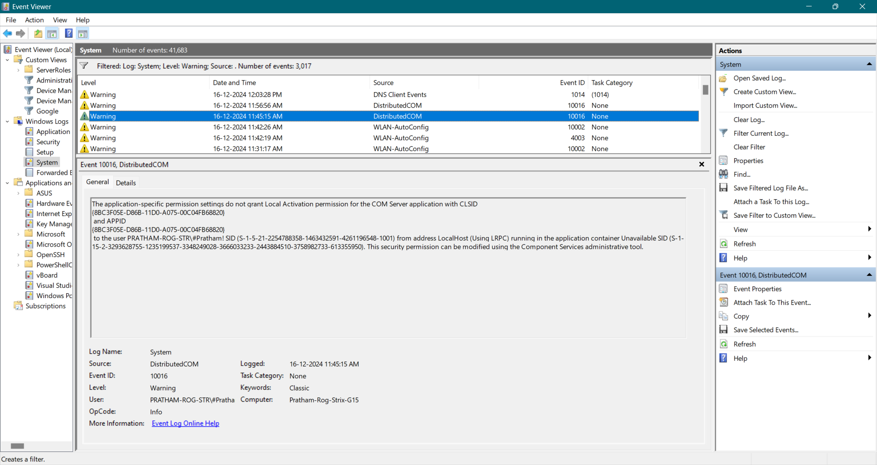

* 1. - Time period (e.g., last 24 hours).

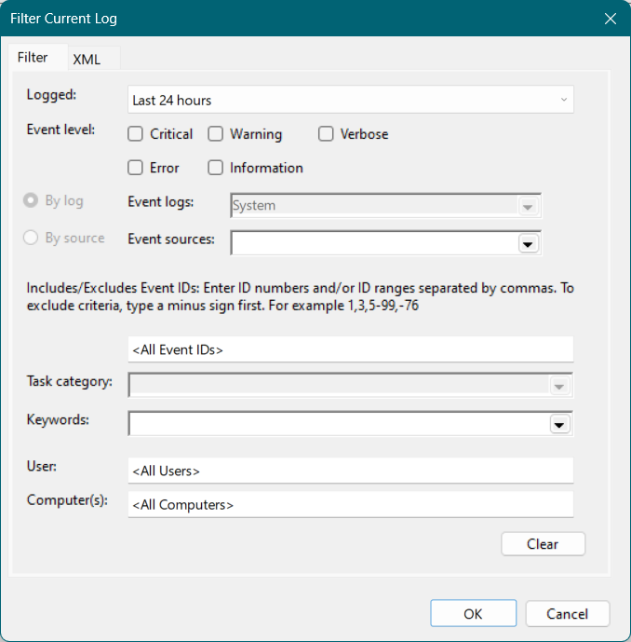

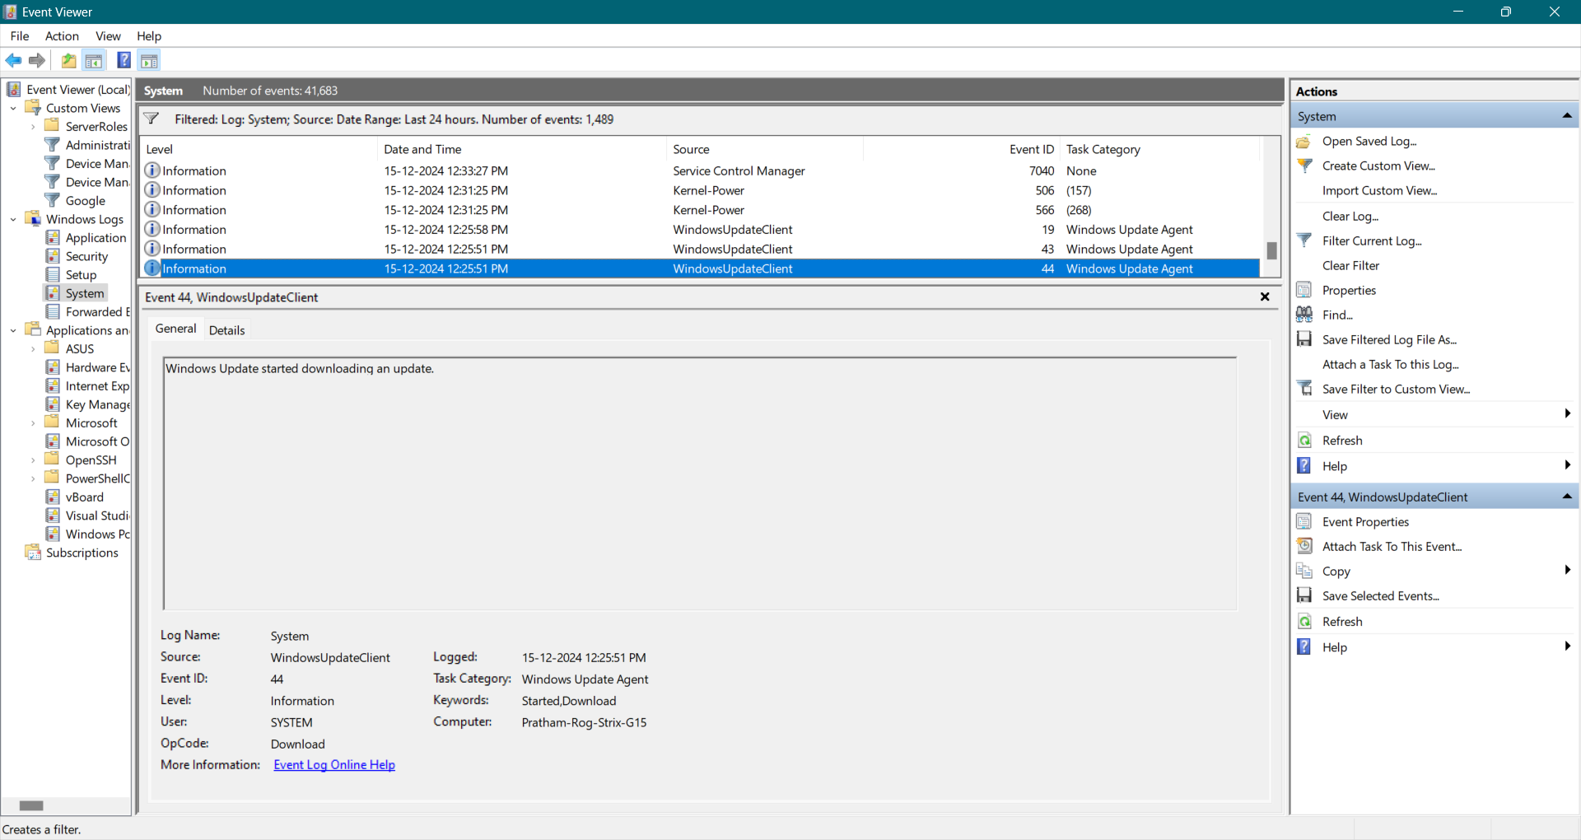

1. Note down a critical or warning event, including the event ID and description.

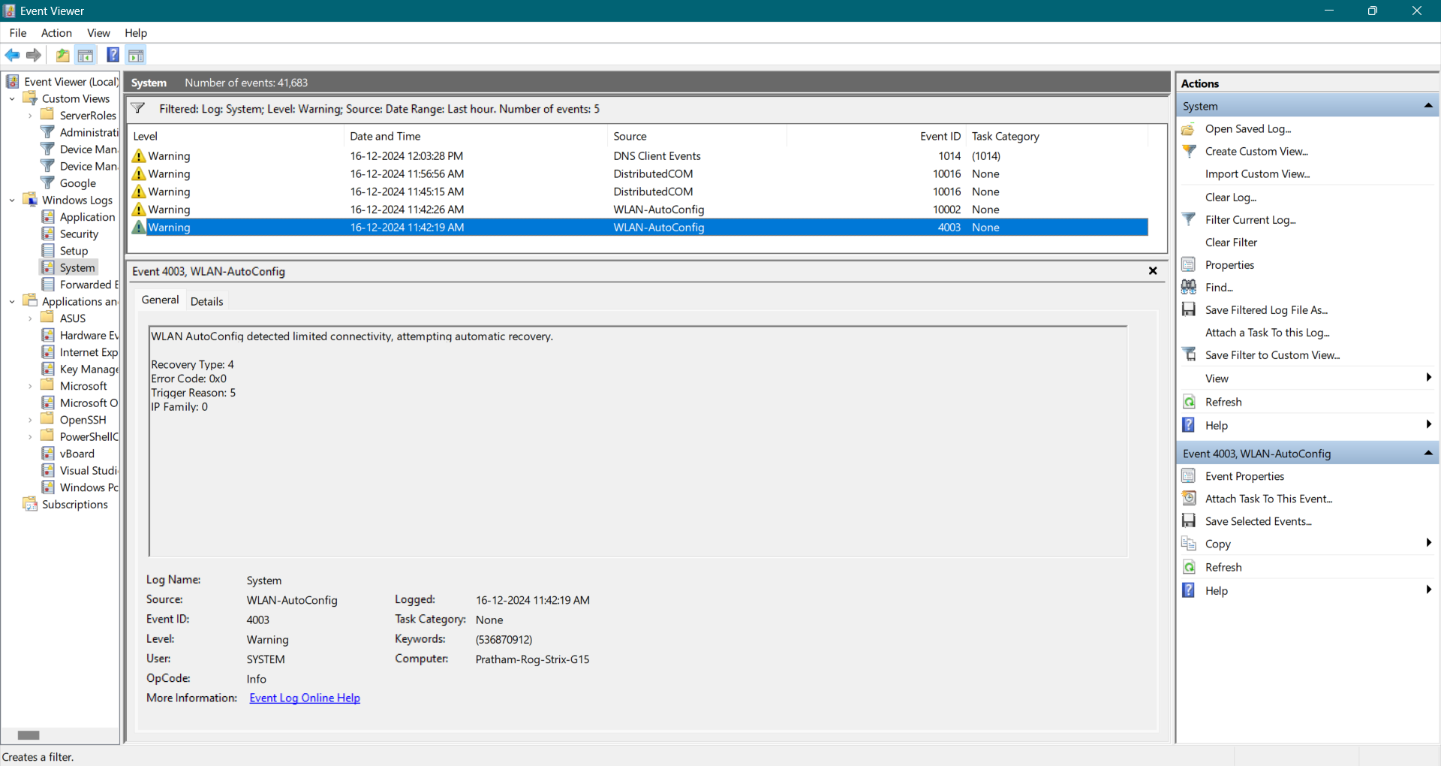

**Warning Event**

**Event ID:** 4003

**Description:**

WLAN AutoConfig detected limited connectivity, attempting automatic recovery.

Recovery Type: 4

Error Code: 0x0

Trigger Reason: 5

IP Family: 0

1. **Outcome:** Learn how to filter and identify specific events.

---------------------------------------------------------------------------------------------------------------------------

**Practical 2: Analyze Boot and Shutdown Events**

**Objective:** Track system boot and shutdown activities.

**Steps:**

1. Navigate to Windows Logs > System.

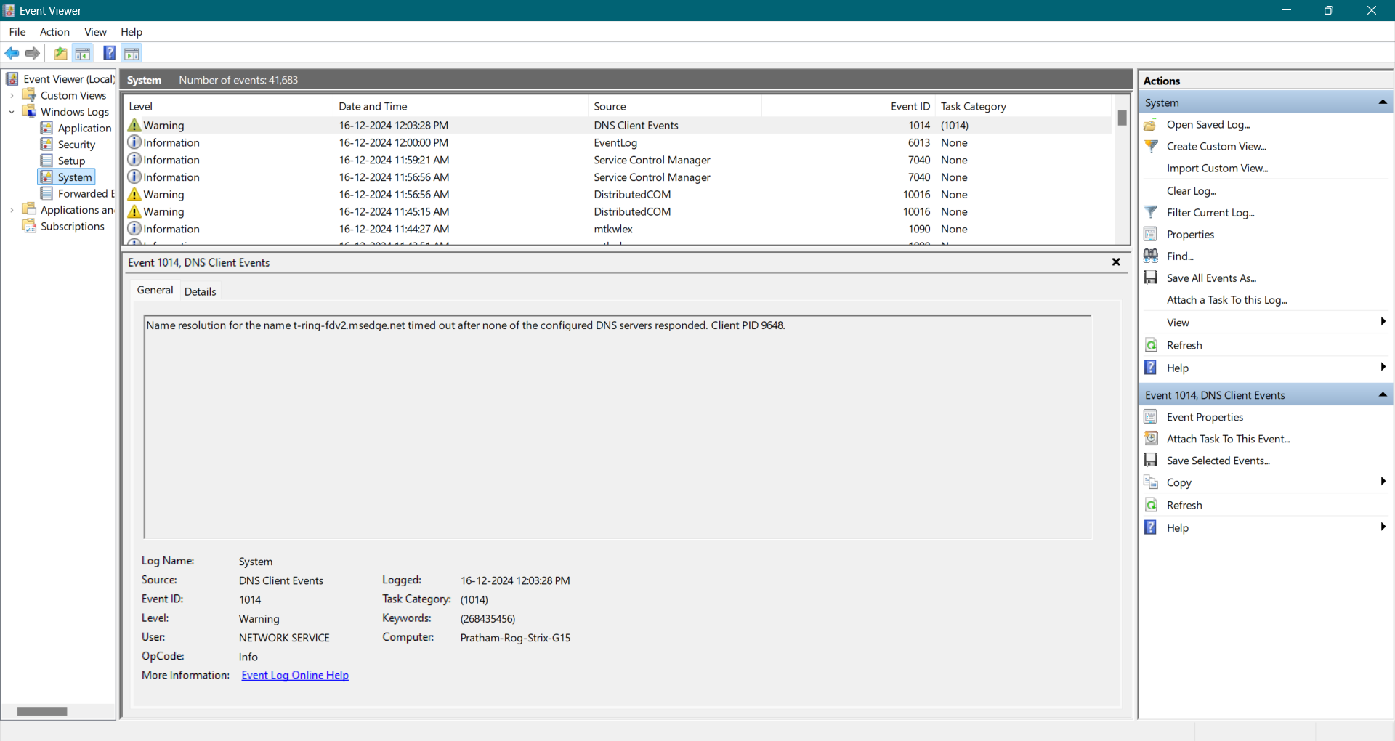

1. Use the following Event IDs to filter:
   1. 6005: System Startup.

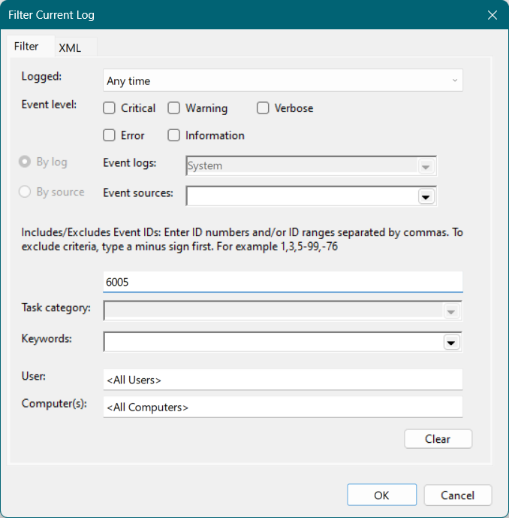

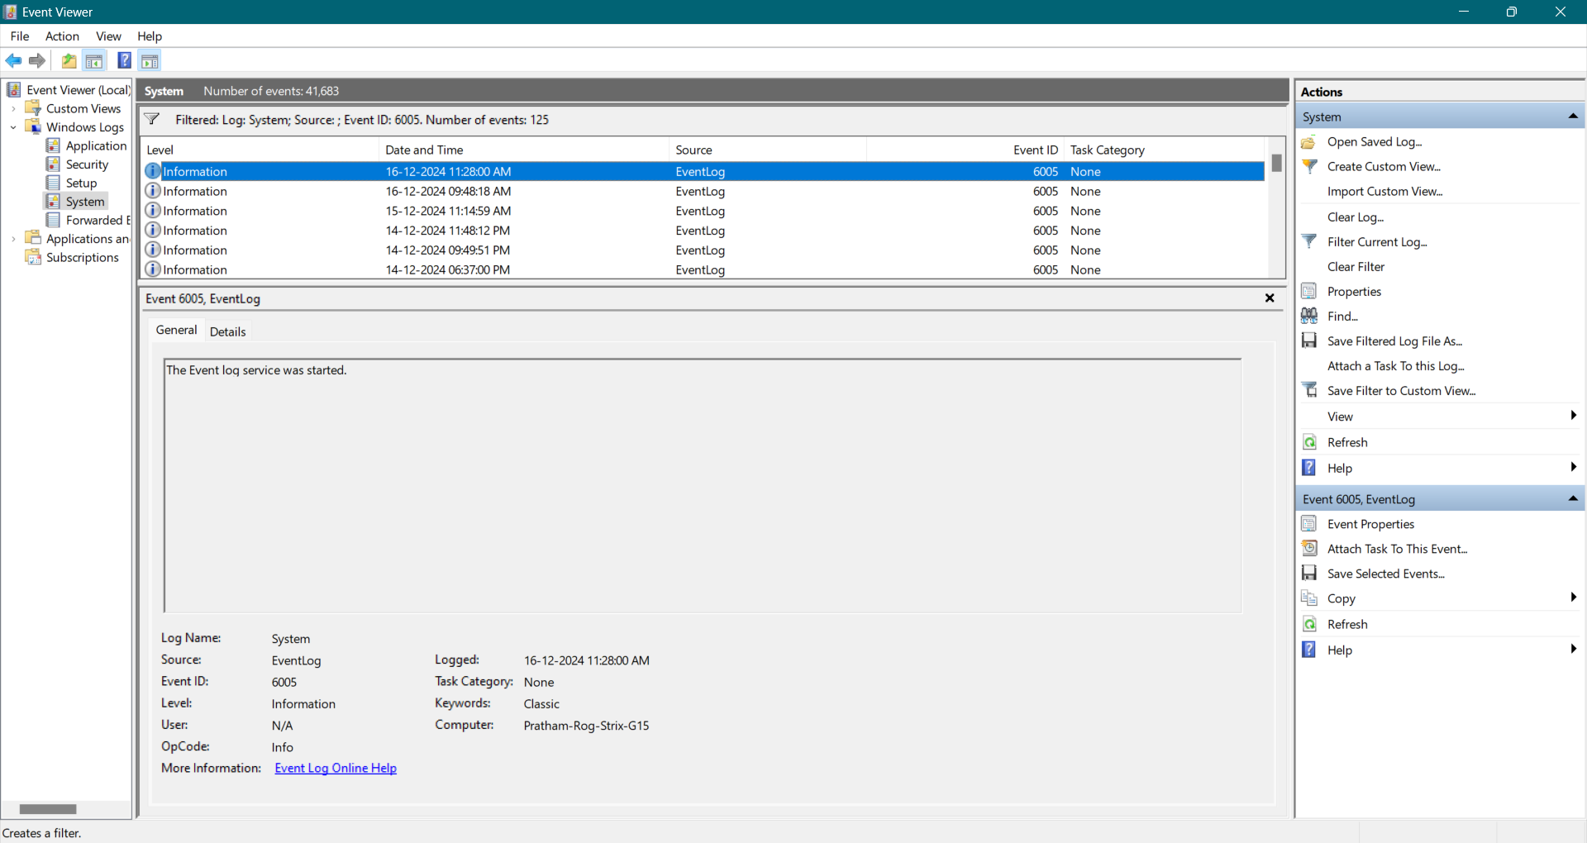

* 1. 6006: System Shutdown.

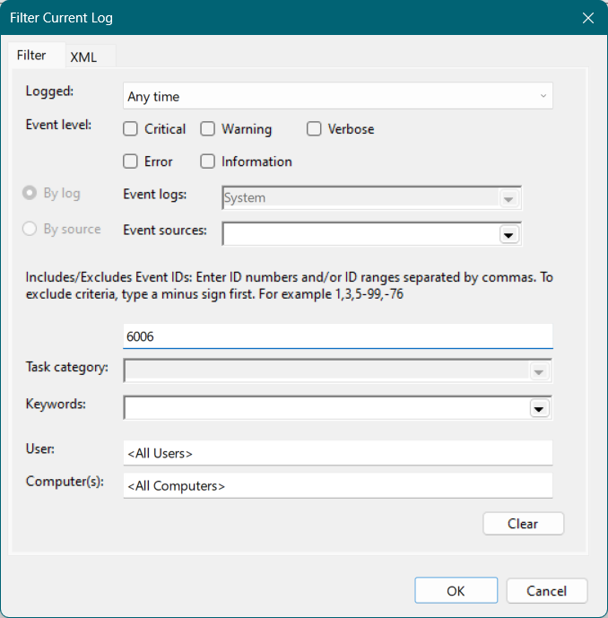

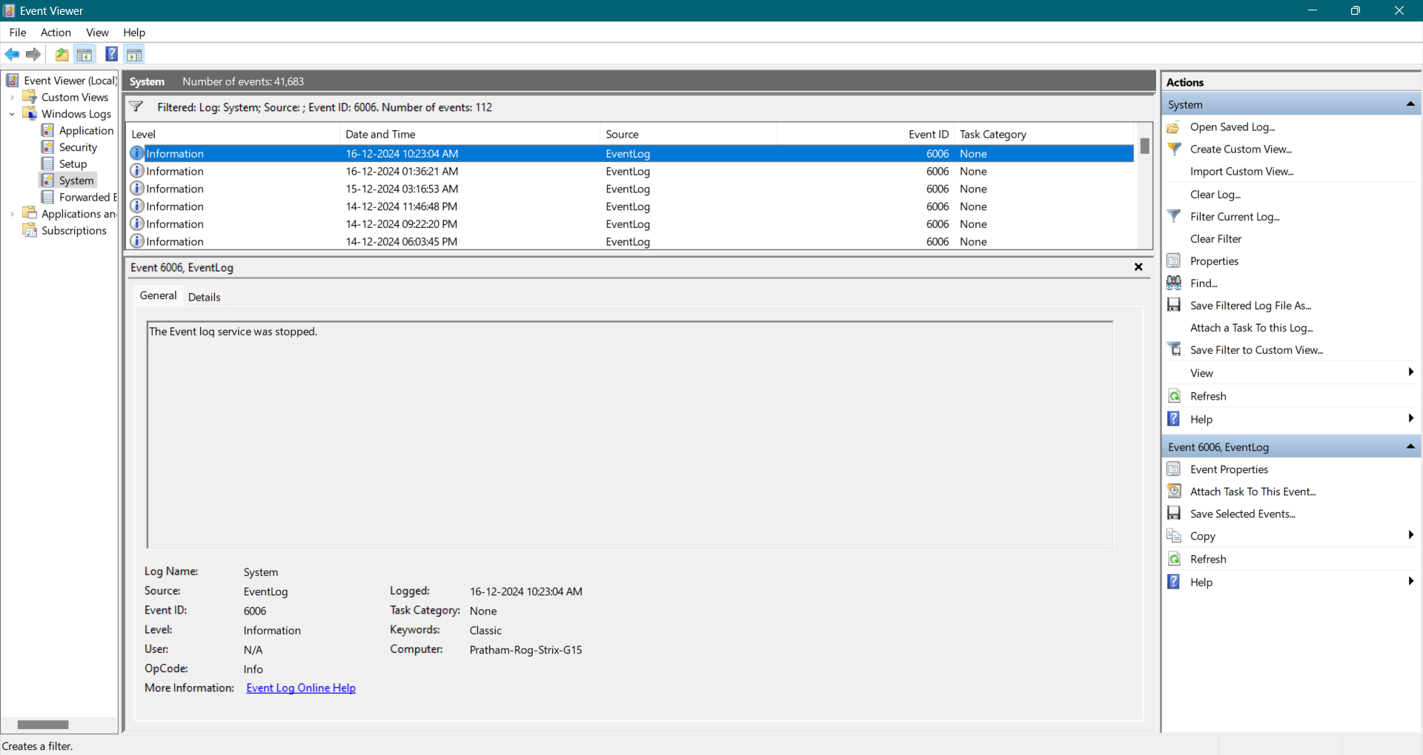

* 1. 6008: Unexpected Shutdown.

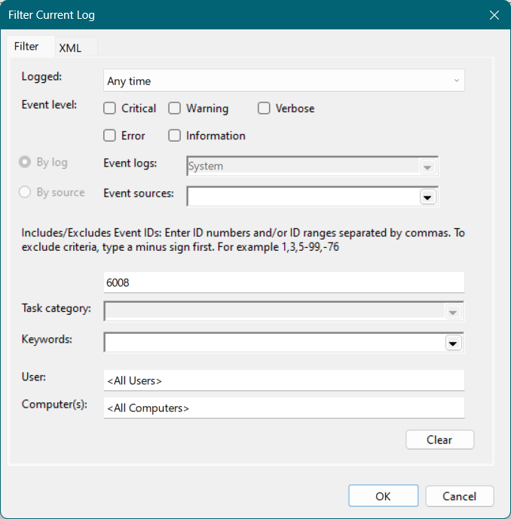

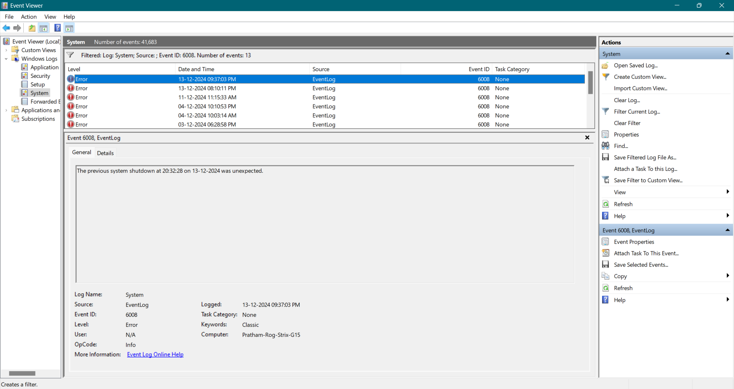

1. Analyze the timestamps to identify system uptime.

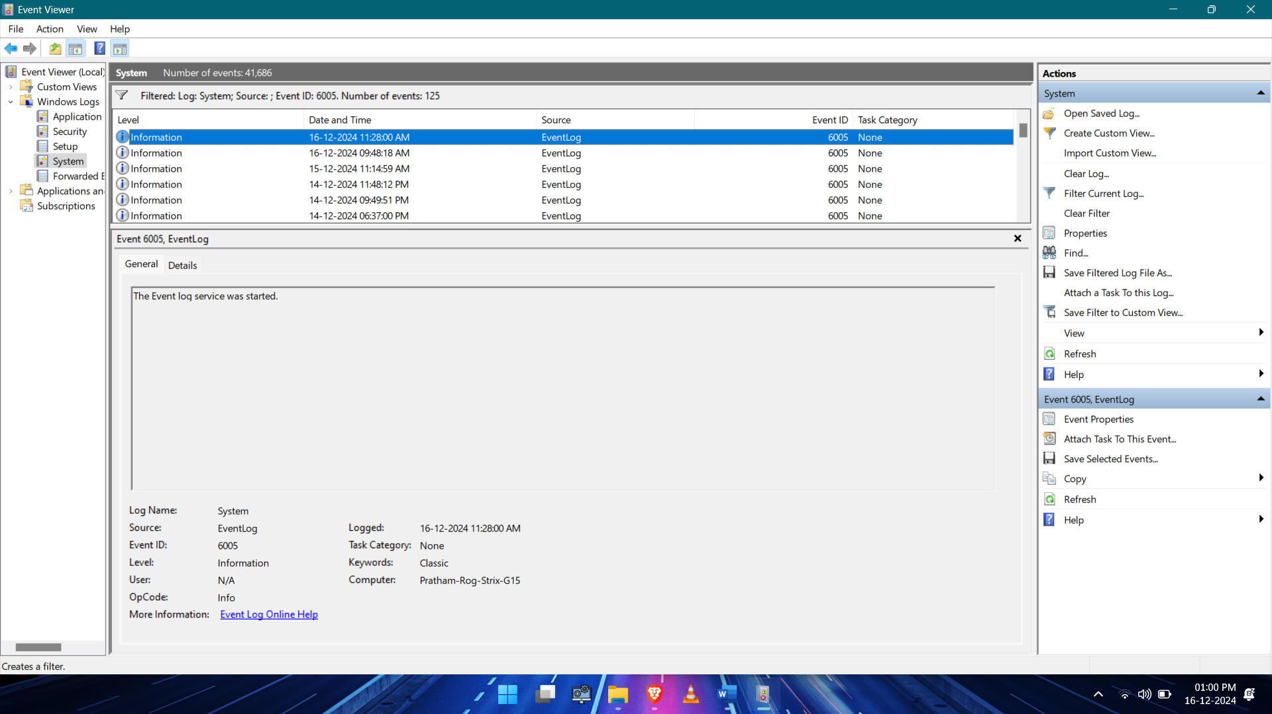

System Startup Time: 16-12-2024 11:28:00 AM

Current Time 16-12-2024 01:00:00 PM

System Uptime: 1 hour 32 minutes

1. Document any abnormal shutdowns with their descriptions.

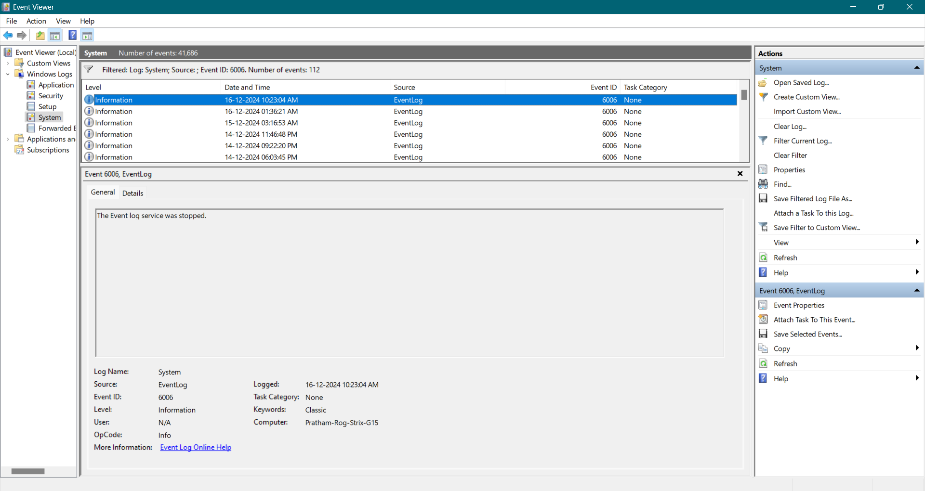

**Event ID:** 6006

**Logged:** 16-12-2024 10:23:04 AM

**Description:** The Event log service was stopped.

1. Outcome: Understand how to monitor system startup and shutdown activities.

---------------------------------------------------------------------------------------------------------------------------

**Practical 3: Audit Logon Events**

**Objective:** Monitor user logon and logoff events.

**Steps:**

1. Navigate to Windows Logs > Security.

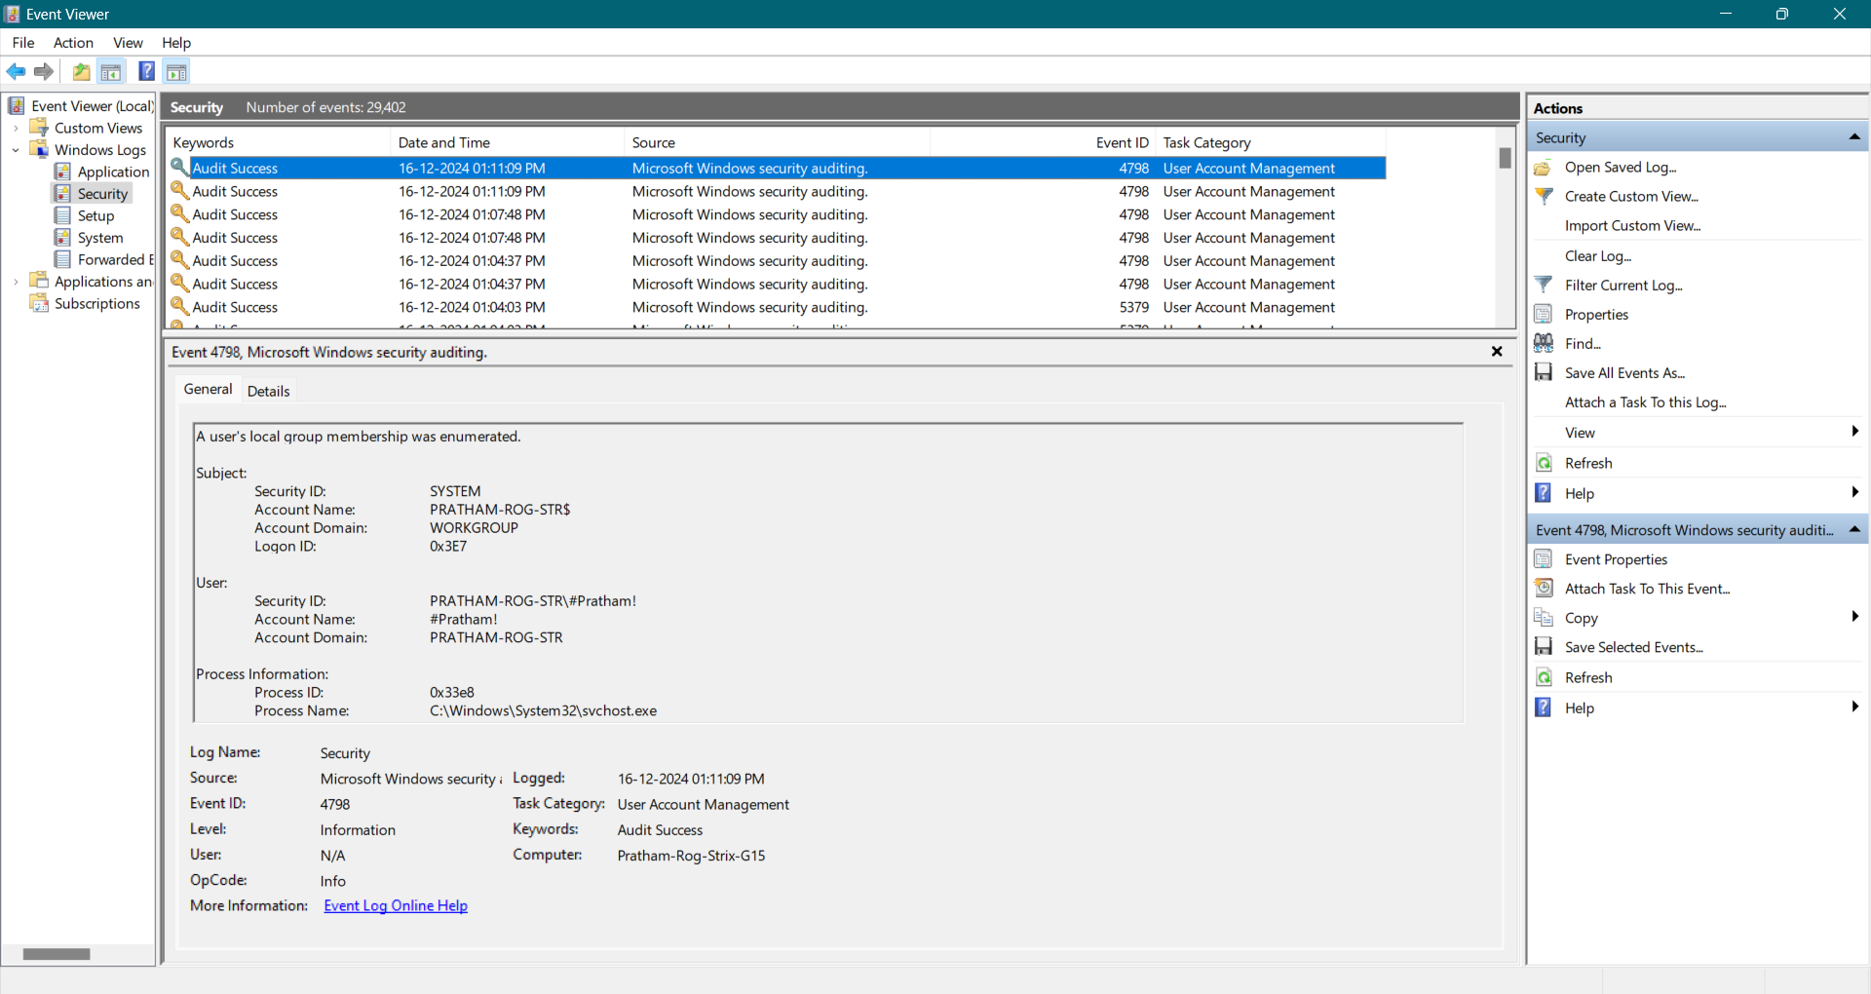

1. Filter by Event IDs:
   1. 4624: Successful logon.

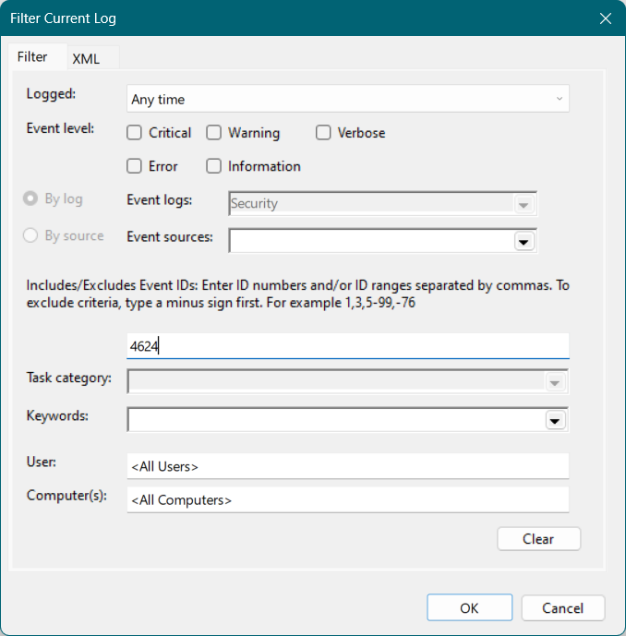

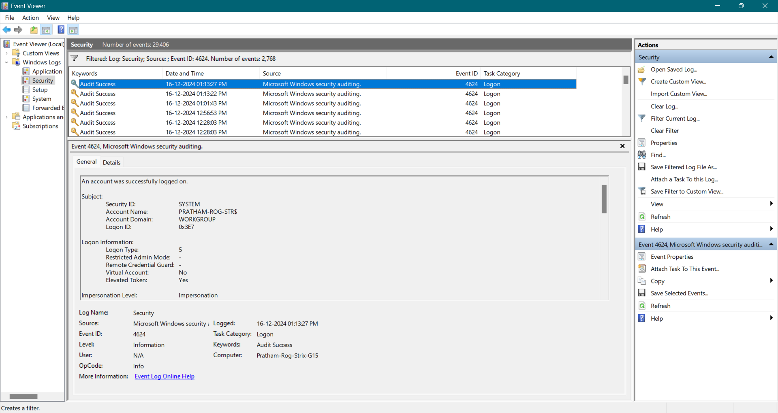

* 1. 4625: Failed logon attempt.

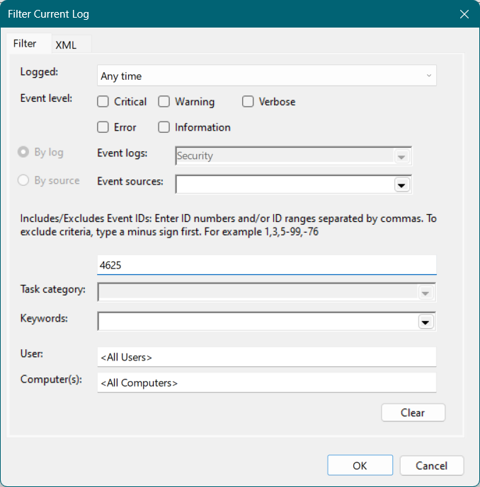

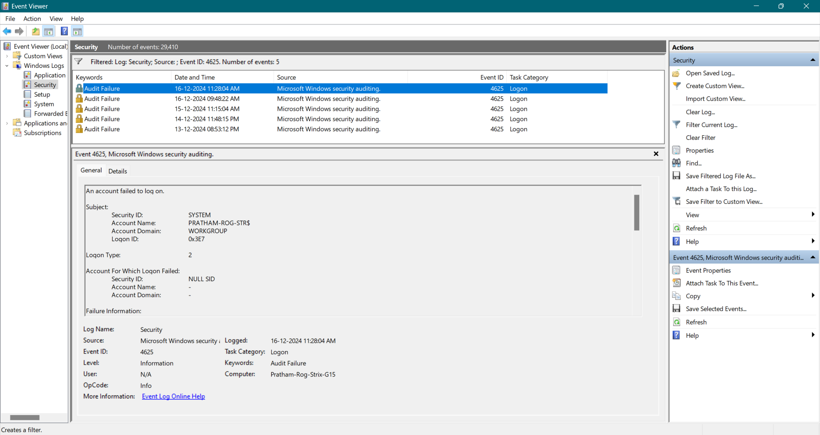

* 1. 4647: User-initiated logoff.

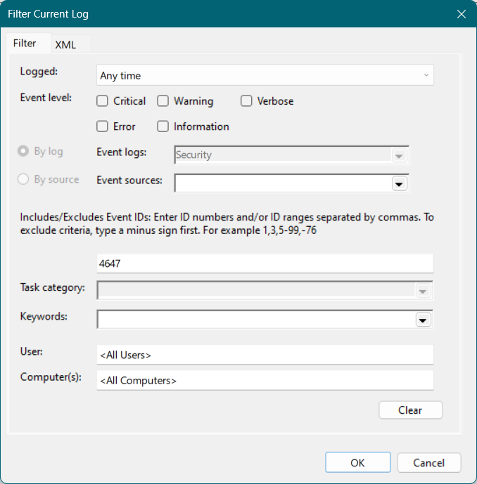

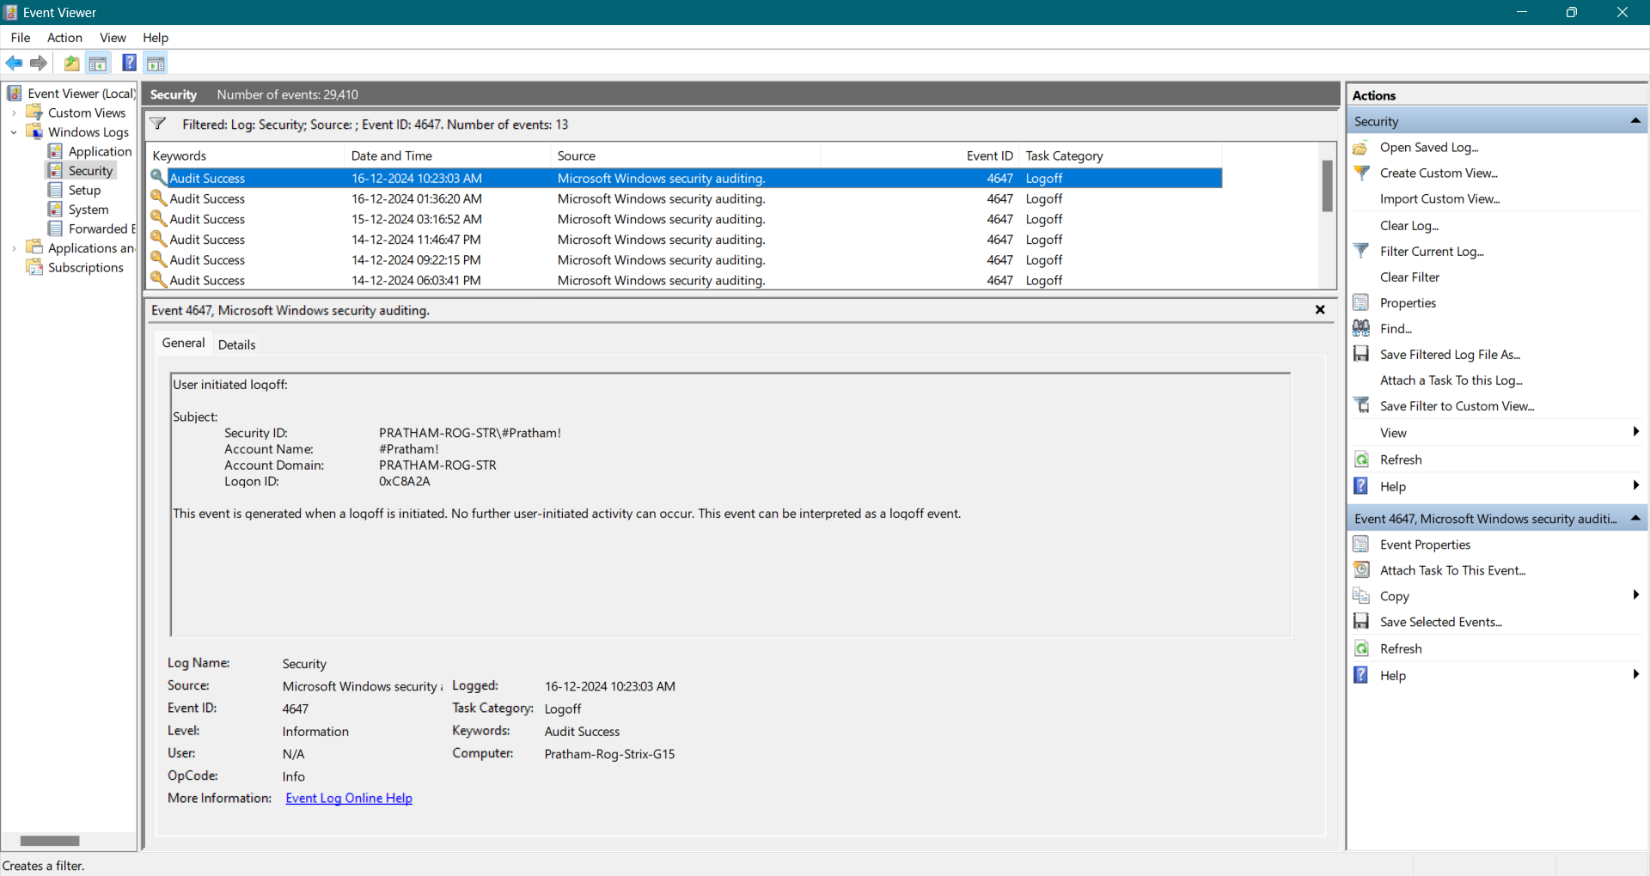

1. Identify:
   1. The user account involved.

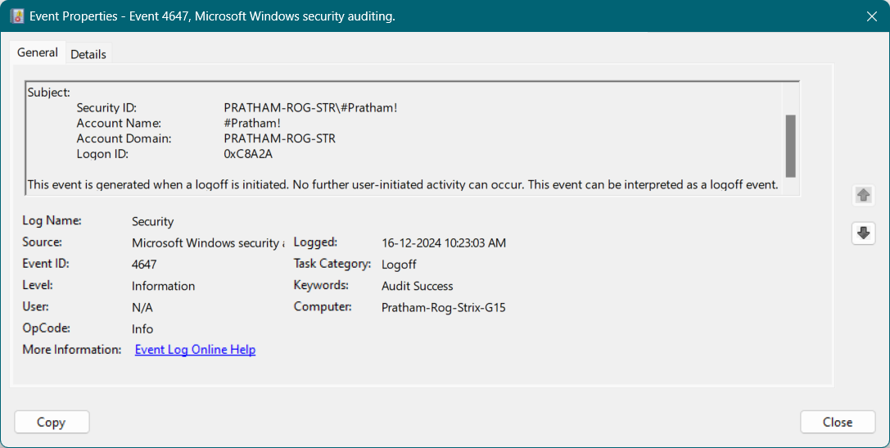

**User:** #Pratham!

* 1. Logon types (interactive, remote desktop, etc.).

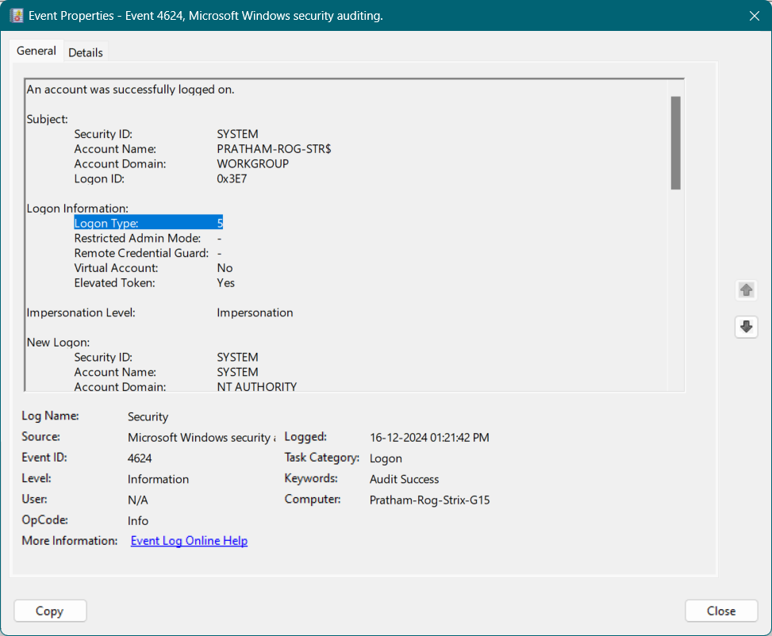

Logon Type: 5 - Service Logon

* 1. Investigate any failed logon attempts for potential security issues.

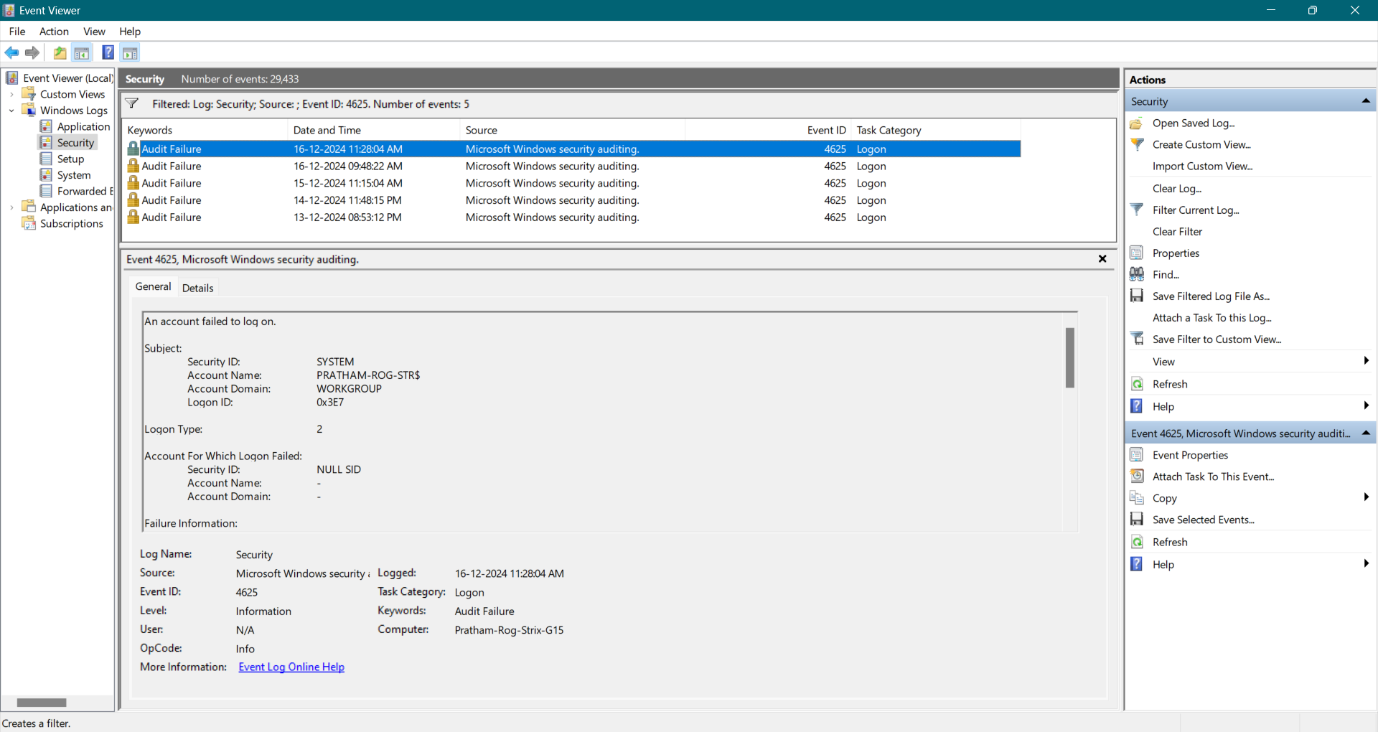

There are only 5 failed login attempts, but any of it are not suspicious.

1. Outcome: Learn to track and audit user authentication.

---------------------------------------------------------------------------------------------------------------------------

**Practical 4: Create a Custom View**

**Objective:** Create a custom view for critical system events.

**Steps:**

1. In Event Viewer, click Action > Create Custom View.

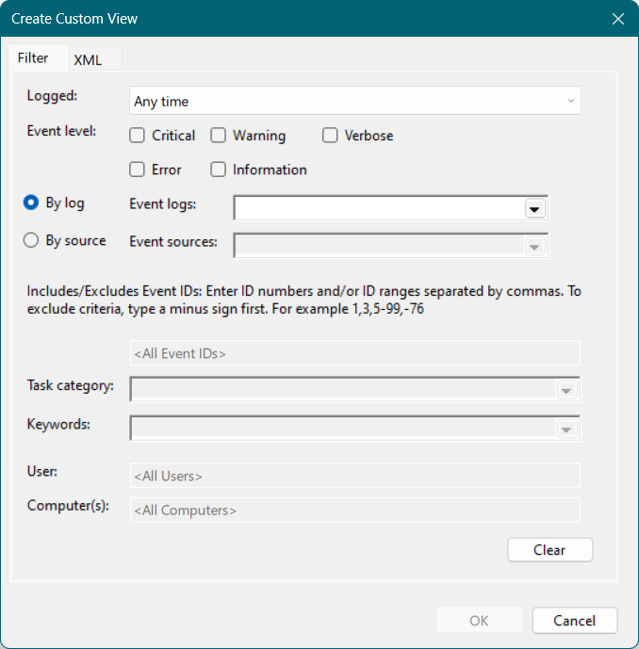

1. Select:
   1. Event Levels: Critical, Warning, and Error.

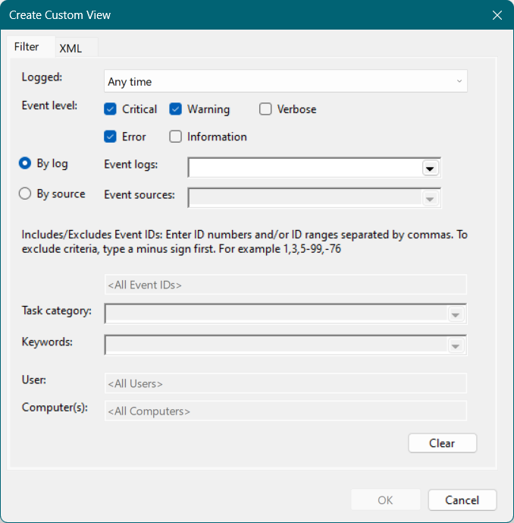

* 1. Logs: System and Application.

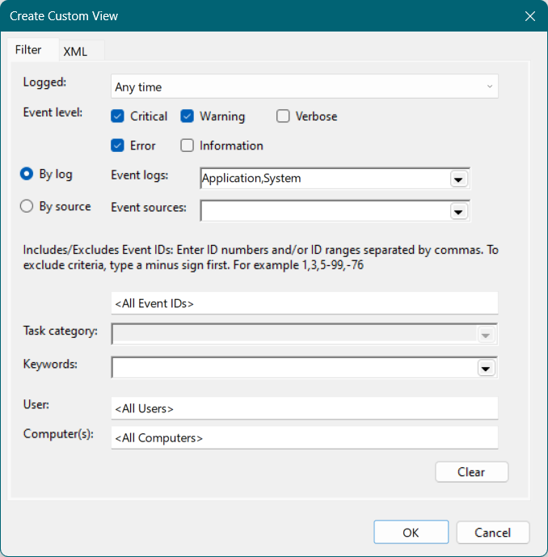

* 1. Time Range: Last 7 days.

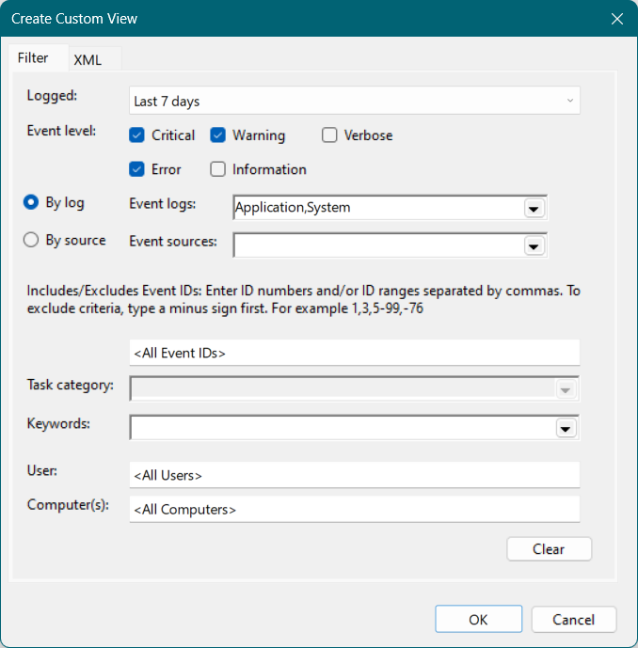

1. Save the custom view with a name (e.g., "Critical System Events").

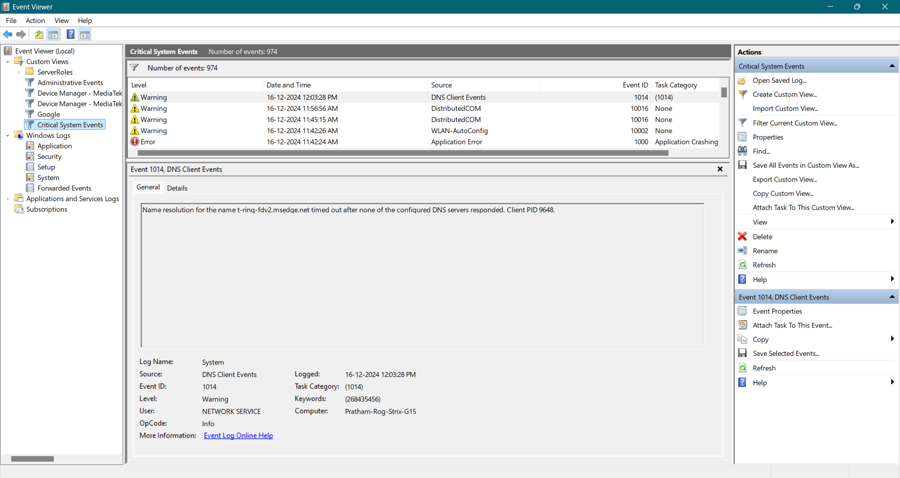

1. Document and analyze any recurring critical errors.

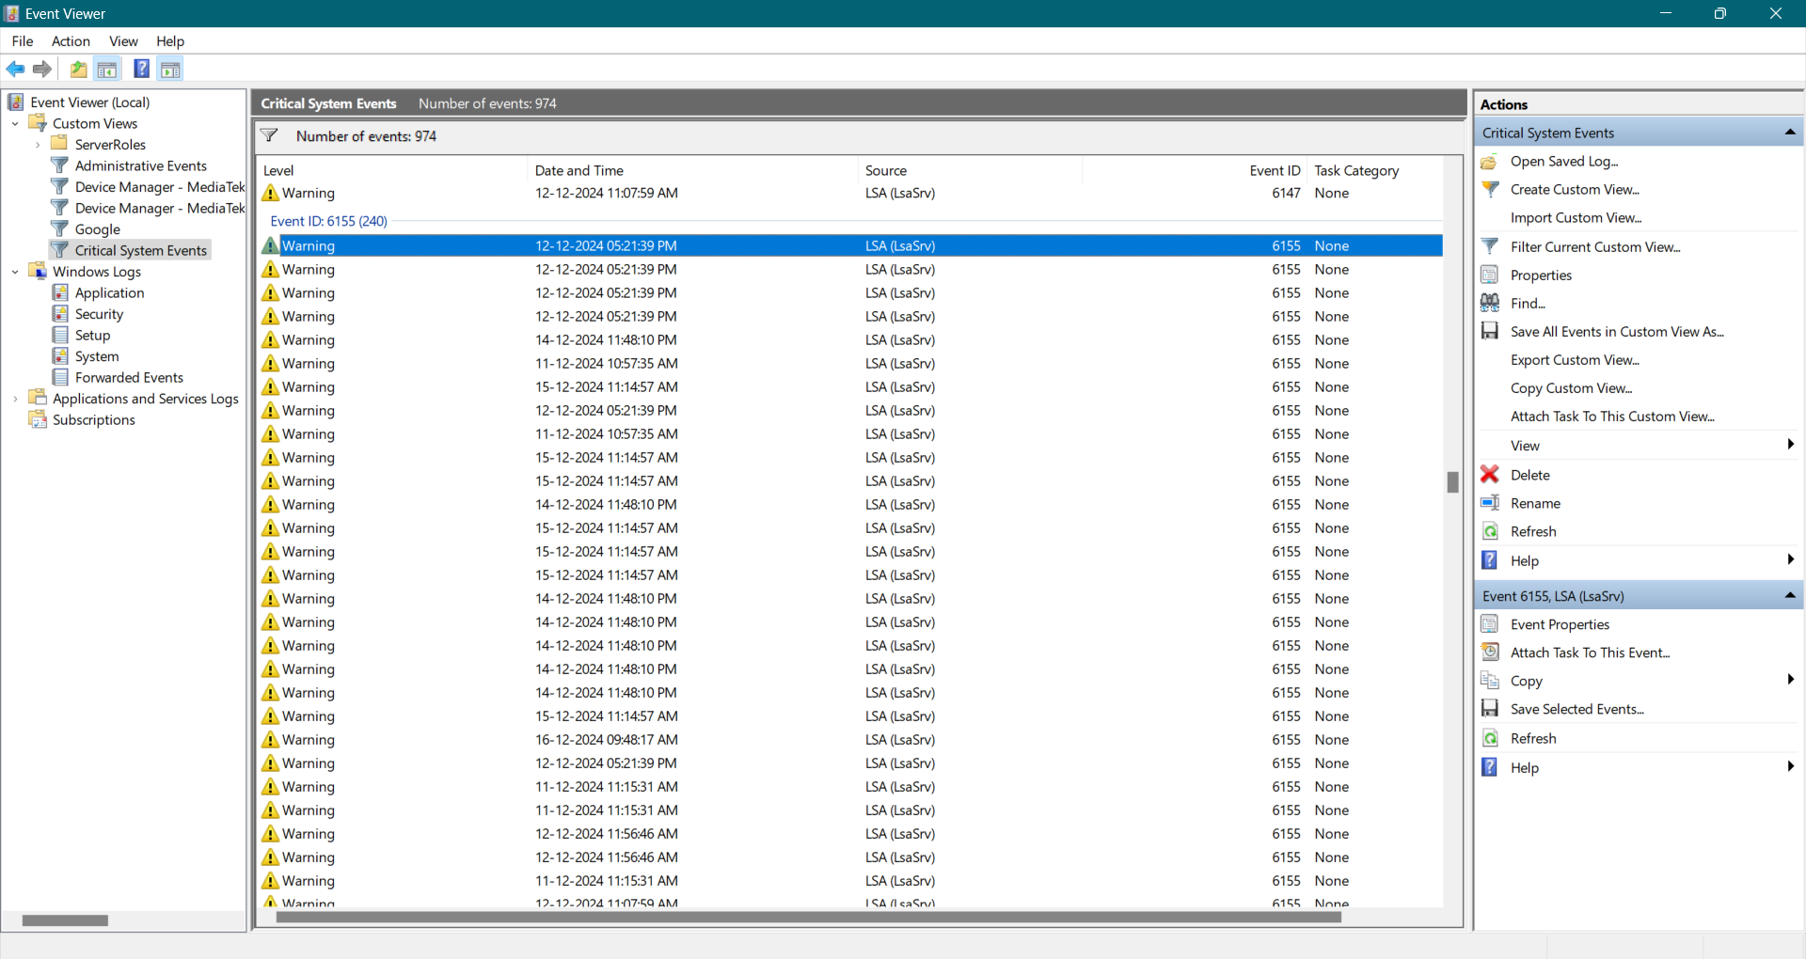

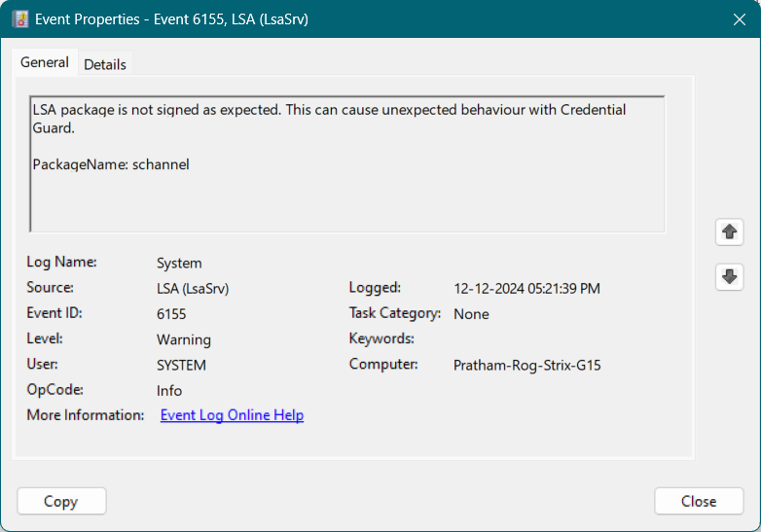

There are ***240 Recurring Logs*** of **Event ID: 6155**

Description:

LSA package is not signed as expected. This can cause unexpected behaviour with Credential Guard.

PackageName: schannel

1. **Outcome:** Learn to customize event views for efficient monitoring.

---------------------------------------------------------------------------------------------------------------------------